**CS2212B – 2018-19**

**Sample UML Questions for the midterm**

**Question 1**: You are given the following UML class diagram. Which of the following object diagrams are consistent with the class diagram?

**1**

**2...**

kdod1_angabe.png

1. B. **C.** D.

kdod1c.png kdod1a.png 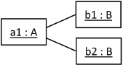 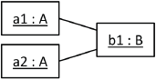

**Question 2**: How do you model the following situation with a UML class diagram:

“A fair is visited by at least one visitor. One visitor visits at least one fair”.

A. B. **C.** D.

cd_clipping06a_en.png cd_clipping06b_en.png cd_clipping06d_en.png cd_clipping06c_en.png

**Question 3**. Which of the following statements about the given diagram are true?

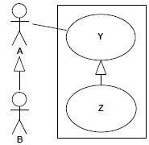

1. A and B should always execute Y together.
2. **A and B can execute Z separately.**
3. A and B should always execute Y or Z together.
4. None of the above.

**Question 4**. The following Use Case Diagram was modeled according to UML2 standard. Which actors communicate with Use Case B?

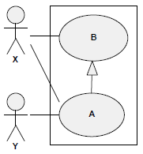

1. **Only X**
2. X and Y
3. Only Y
4. X and X and Y

**Question 5**. With which use cases does actor T communicate - no matter if other actors are also involved?

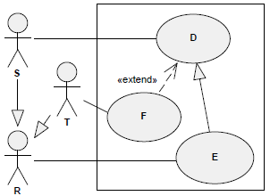

1. Only F
2. **F and E**
3. D
4. D and F and E

**Question 6.** The following Use Case Diagram was modeled according to UML2 standard. Which actors communicate with Use Case G?

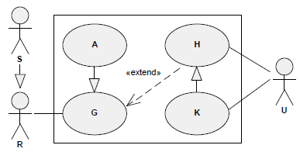

1. Only R
2. Only S
3. **S and R**
4. S and R and U

**Question 7.** Which of the following statements about the given diagram clipping are true?

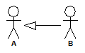

1. *B inherits all of A's associations.*
2. A inherits all of B's associations.
3. *B can execute the same use cases as A.*
4. **Cases A and C above**

**Question 8**. The following Use Case Diagram was modeled according to UML standard. Which actors will *always* communicate with Use Case D?



1. S and R.
2. S and T.
3. **Only S.**
4. R and T.

**Question 9**. The following Use Case Diagram was modeled according to UML2 standard. Which actors can communicate with Use Case E?



1. Only S
2. Only R.
3. Only T
4. **R, and T, and S**

**Question 10**. The following Use Case Diagram was modeled according to UML2 standard. Which combinations of actors communicate with Use Case A?

1. X ∧ X
2. Y ∧ Y ∧ Y
3. Y
4. X ∧ X ∧ X
5. X ∧ Y
6. **X**
7. X ∧ Y ∧ Y
8. Y ∧ Y
9. X ∧ X ∧ Y

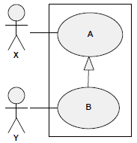

**Question 11**. How do you model the following situation with a UML use case diagram: “A mother cooks dinner together with her daughter. In the course of that, it is the mother who also always has to mix the cocktails”.

A. B. **C.** D.

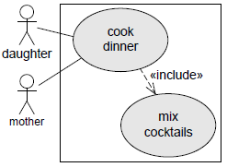 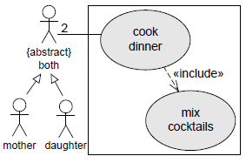 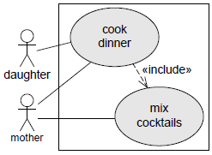 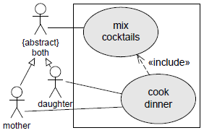

**Question 12**. How do you model the following situation with a UML use case diagram: “A student edits her user profile. In the course of that she can also change her password if she likes.

A. B. **C.** D.

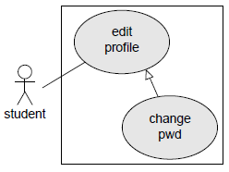 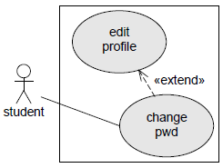 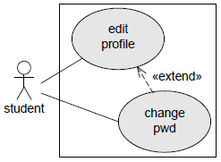 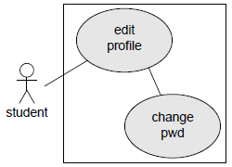

**Question 13**: You are given the following activity diagram. Which of the following action sequences are possible during one execution of the activity diagram?

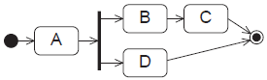

1. The sequence A🡪 B 🡪 C 🡪 D
2. The sequence A 🡪 B 🡪 C
3. The sequence A 🡪 B 🡪 D
4. **Answers “B” and “C” above**

**Question 14.** You are given the following activity diagram. Which of the following action sequences are possible during one execution of the activity diagram?

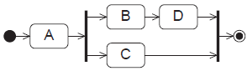

1. The sequence A → C
2. **The sequence A → C → B → D**
3. **The sequence A → B → D → C**
4. **The sequence A → B → C → D**
5. A → B → D (C also has to be executed before the flow is synchronised and reaches the final node)

adNotation2c.png Fork Node (outgoing flows proceed concurrently)

adNotation2a.png Decision node (one outgoing flow will be selected)

adNotation2d.png Join node (concurrent flows have to be synchronized here)

adNotation2b.png Merge node (one incoming flow will be selected)

**Question 15.** You are given the following activity diagram. Which of the following action sequences are possible during one execution of the activity diagram?

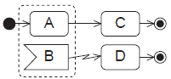

1. The sequence A → B → D → C
2. **The sequence A → C**
3. **The sequence A → B → D**
4. The sequence A → B → C (If event B occurs while A is executed, all activity in the region (within the pointed rectangle) is terminated and control is transferred to the interrupt handler activity node D).

**Question 16.** You are given the following activity diagram. Which of the following action sequences are possible during one execution of the activity diagram?

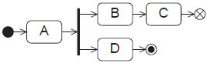

1. **The sequence A → B → C → D**
2. **The sequence A → D**
3. **The sequence A → B → D**
4. The sequence A → B → D → C
5. The sequence A → B → C (The flow final node after C only terminates this thread, D also has to be completed to reach the activity final node and terminate the whole graph)

**Question 17.** Which of the following activity diagram clippings are correct considering the control flow? (token concept!)

**A.** B.

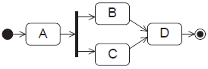 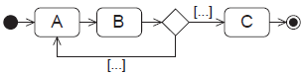

**C.** **D.**

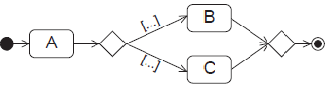 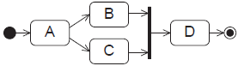

**E.**  F.

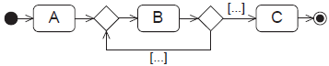 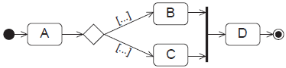

Correct choices are bold and underlined.

**Question 18**: You are given the following two sequence diagram. Which diagrams are posssible?

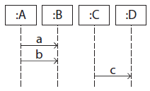

a

b

c

d

d’

e



a

b

c

d

c’

d’

S1 S2

1. **Only S1**
2. Only S2
3. Both
4. None of the above

**Question 19.** You are given the following sequence diagram. Which traces are possible?

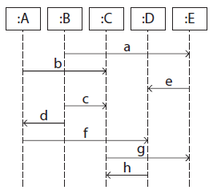

1. **The sequence a → b → c → e → d → g → f → h**
2. **The sequence b → a → c → d → e → f → g → h**
3. The sequence a → c → b → e → d → f → g → h (b has to be sent before c)
4. None of the above

**Question 20.** You are given the following sequence diagram. Which operations does class A have according to the diagram?

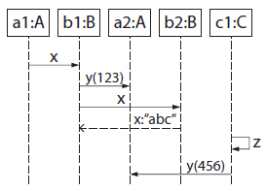

1. x(String):void
2. x(void)
3. x():int
4. y():int
5. z():void
6. x():String
7. **y(int):void**
8. z():int
9. x():void
10. y():void

**Question 21.** You are given the following sequence diagram. Which traces are possible?

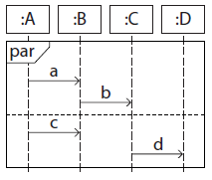

1. **The sequence c → a → d → b**
2. The sequence b → a → c → d (a must be received before d can be sent, because a is placed higher on the lifeline of B)

**Question 22.** You are given the following sequence diagram. Which traces are possible?

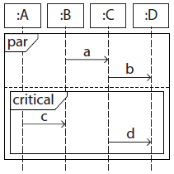

1. **The sequence a → b → d → c**
2. The sequence c → a → b → d (a and b must not interleave with the messages within the critical fragment)
3. **The sequence a → b → c → d**
4. The sequence a → c → b → d (b must not interleave with the messages within the critical fragment)
5. **The sequence d → c → a → b**
6. The sequence d → a → b → c (a and b must not interleave with the messages within the critical fragment)
7. **The sequence a → c → d → b**

**Question 23.** You are given the following sequence diagram. Which traces are possible?

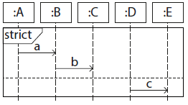

1. The sequence b → c → a
2. The sequence b → a → c
3. **The sequence a → b → c**
4. The sequence c → b → a

**Question 24.** You are given the following sequence diagram. Which traces are possible?

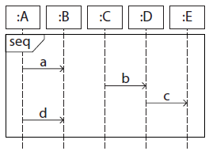

1. The sequence a → d → c → b (b must be received before c can be sent)
2. **The sequence b → a → c → d**
3. The sequence a → c → b → d (b must be received before c can be sent)
4. The sequence d → a → c → b (a must be sent and received before d can be sent. b must be received before c can be sent)
5. **The sequence b → a → d → c**
6. **The sequence b → c → a → d**
7. **The sequence a → b → c → d**
8. **The sequence a → d → b → c**

**Question 25.** You are given the following sequence diagram. Which traces are possible?

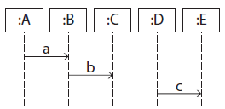

1. The sequence b → a → c (a must be received before b can be sent)
2. The sequence c → b → a (a must be received before b can be sent)
3. The sequence b → c → a (a must be received before b can be sent)
4. **The sequence a → b → c**
5. **The sequence a → c → b**
6. **The sequence c → a → b**

These are taken from <http://elearning.uml.ac.at/> It is strongly advised to go over the on-line quizzes to strengthen your UML understanding. Additional UML material can be found at <http://www.agilemodeling.com/artifacts/> (see towards the end of the list the entries about UML artifacts)